# Adaptive introgression during environmental change can weaken reproductive isolation

## 

Gregory L. Owens1*, Kieran Samuk2

## 

1 Department of Integrative Biology, University of California, Berkeley.

Berkeley, California, USA, 94720.

2 Department of Biology, Duke University.

Durham, NC, USA, 27708.

*Corresponding author, [gregory.lawrence.owens@gmail.com](mailto:gregory.lawrence.owens@gmail.com)

## **Supplementary Figures**

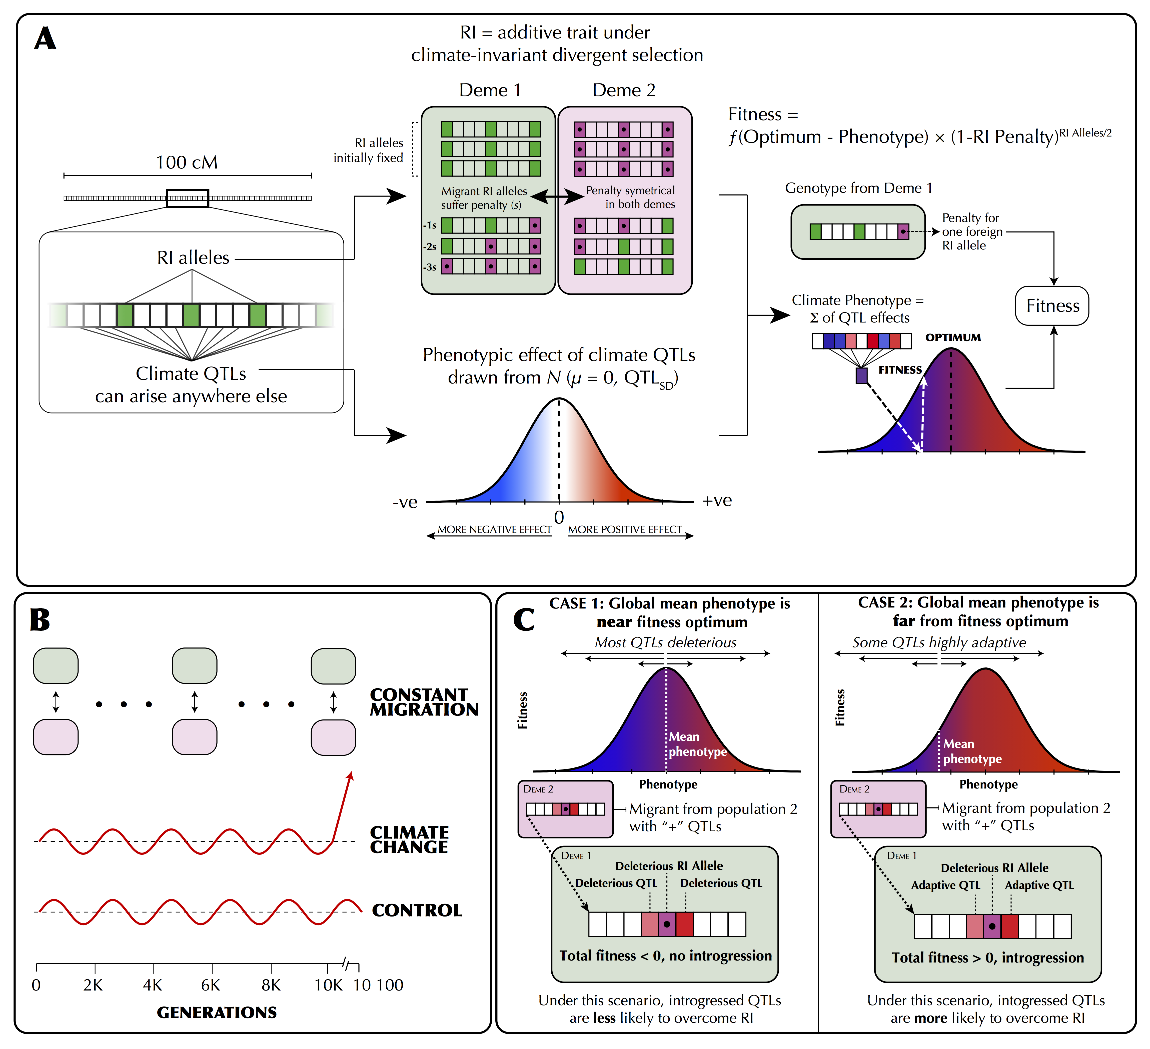

**Supplementary Figure 1 | A graphical outline of the simulation.**

(A) The genetic architecture of adaptation and speciation in the model. From left to right: Each individual has a single 100-1000 cM chromosome, over which reproductive isolation (RI) loci occur at regularly-spaced intervals. These loci are initialized with RI alleles (at 100% frequency) that confer local adaptation to one of two initial demes (depicted as green or purple/dotted alleles, corresponding to Deme 1 or Deme 2 environments). Both demes are of equal size (*Ne* = 1000). All non-RI loci (depicted as white/transparent loci, initially) have the potential to give rise to climate-adaptation alleles. The phenotypic effects of each these alleles are drawn from a normal distribution (shown as a gradient from blue to white to red). An individual's climate phenotype is the sum of the phenotypic effects of its climate QTLs (pure additivity). The fitness of each individual is a function of the number of foreign RI alleles and the phenotypic distance of that individual from the environmental optimum, with the climate fitness landscape modelled as a gaussian distribution (shown as a gradient from blue to red). (B) The course of the simulation. Migration rate and population size of the two demes is held constant. In each replicate simulation, the fitness optimum fluctuates regularly for a 10 000-generation burn-in period. The state of the initial population is then duplicated and subjected to 100 additional generations of (1) a climate change scenario in which the climatic optimum rapidly shifts in a single direction and (2) a control scenario in which the optimum continues its fluctuation course. (C) The conditions under which adaptive introgression overwhelms RI. On the left, if the two populations are able to individually track the climatic optimum, newly-arising climate alleles are only able to exert either weakly positive or (more commonly) negative effects on fitness due to overshooting the optimum. In contrast, on the right, if the populations cannot effectively track the optimum, there is scope for climatic alleles to have large positive fitness effects. If these fitness effects are sufficiently large, these alleles can overwhelm the negative fitness effects of linked RI alleles and introgress between demes, degrading overall reproductive isolation

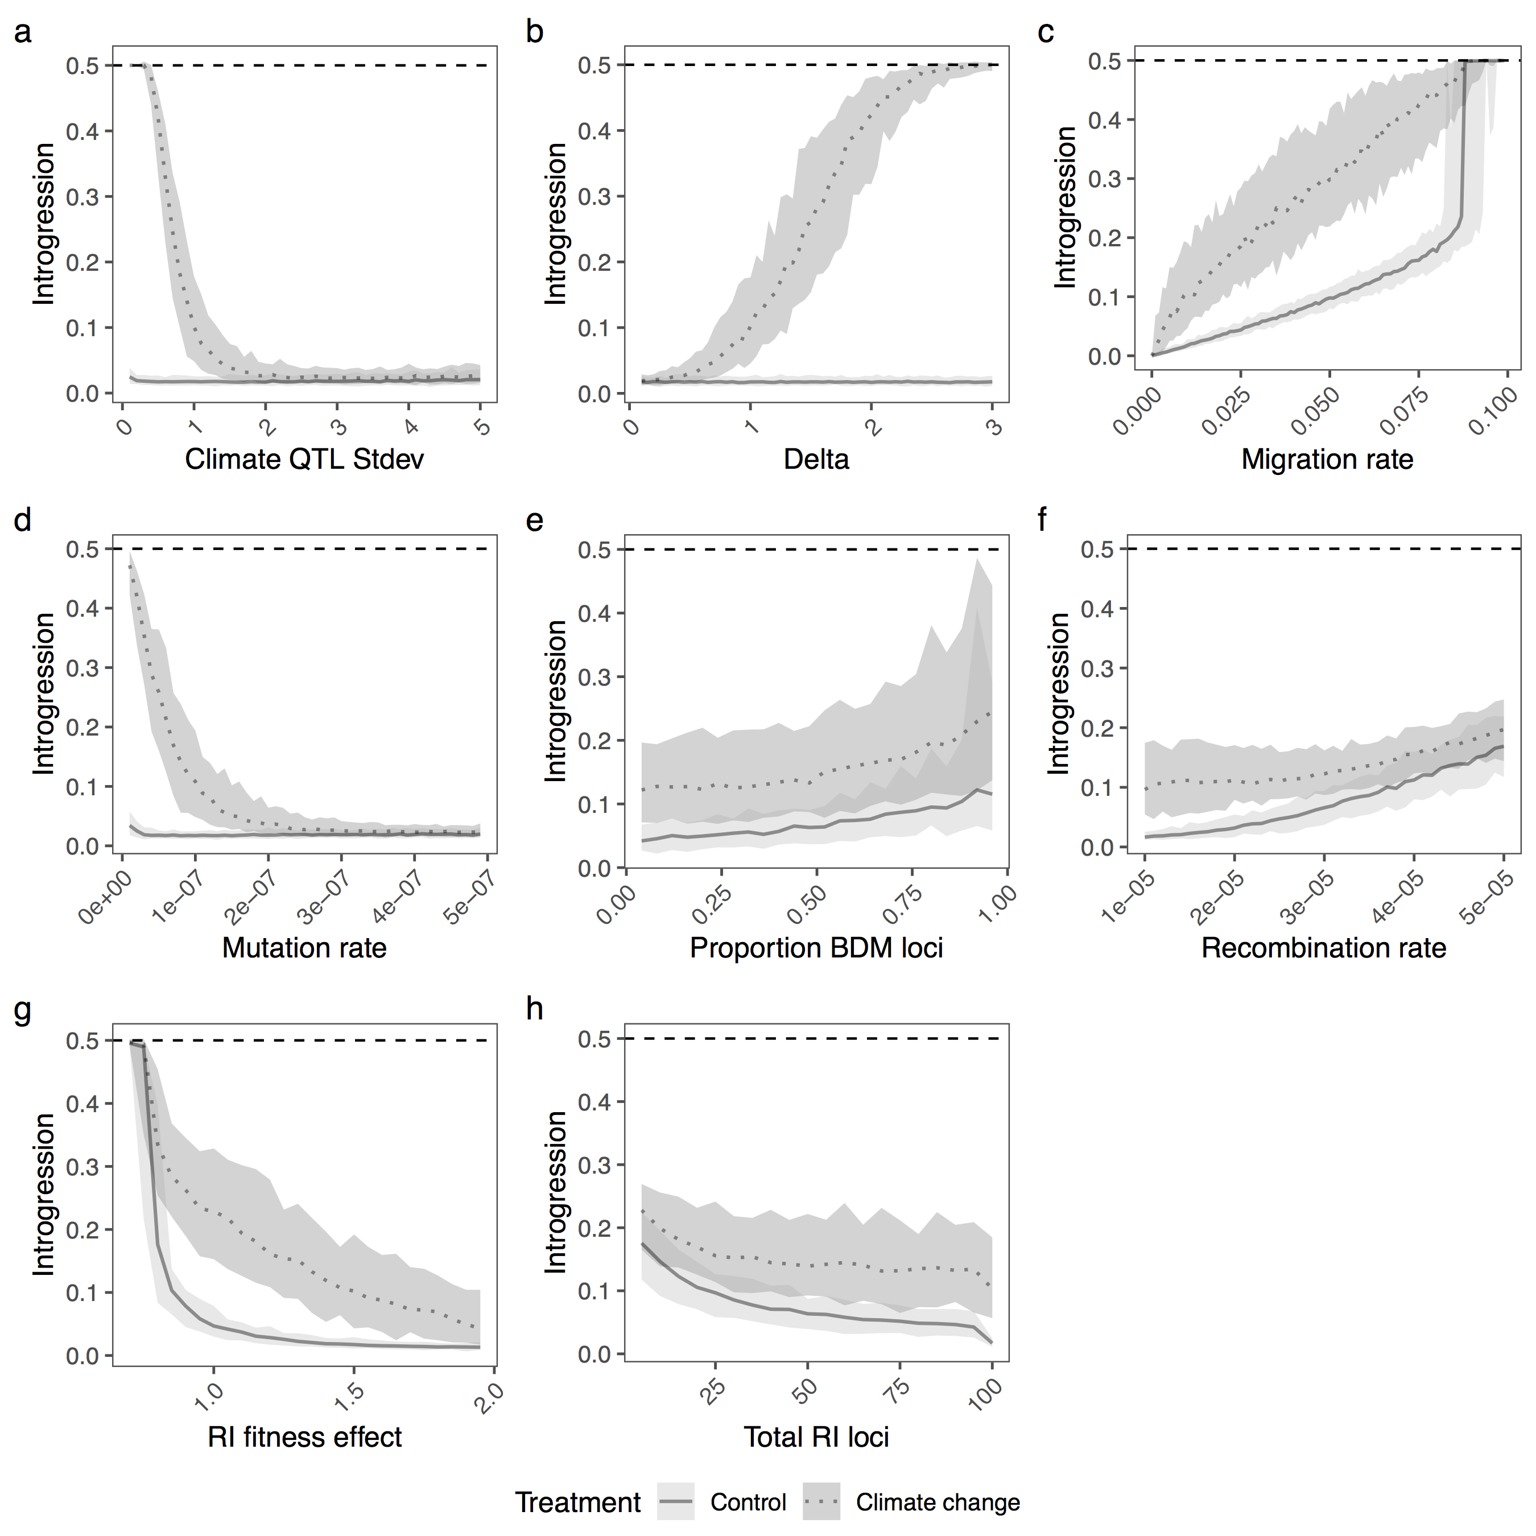**Supplementary Figure 2 | The amount of introgression during climate change.**  
The average amount of introgression at generation 10,100 for climate change (dotted dark) and control simulations (solid light), while varying individual parameters. The shaded area encompasses 95% of the simulations. Complete homogenization of both populations occurs when average introgression = 0.5. Individual parameters were varied to show the effect of (a) climate QTL effect size standard deviation, (b) optimum shift per generation (delta), (c) migration rate, (d) climate QTL mutation rate, (e) proportion of RI loci that are BDM instead of extrinsic, (f) the recombination rate, (g) the fitness effect of each RI loci and (h) the number of RI loci.

## 

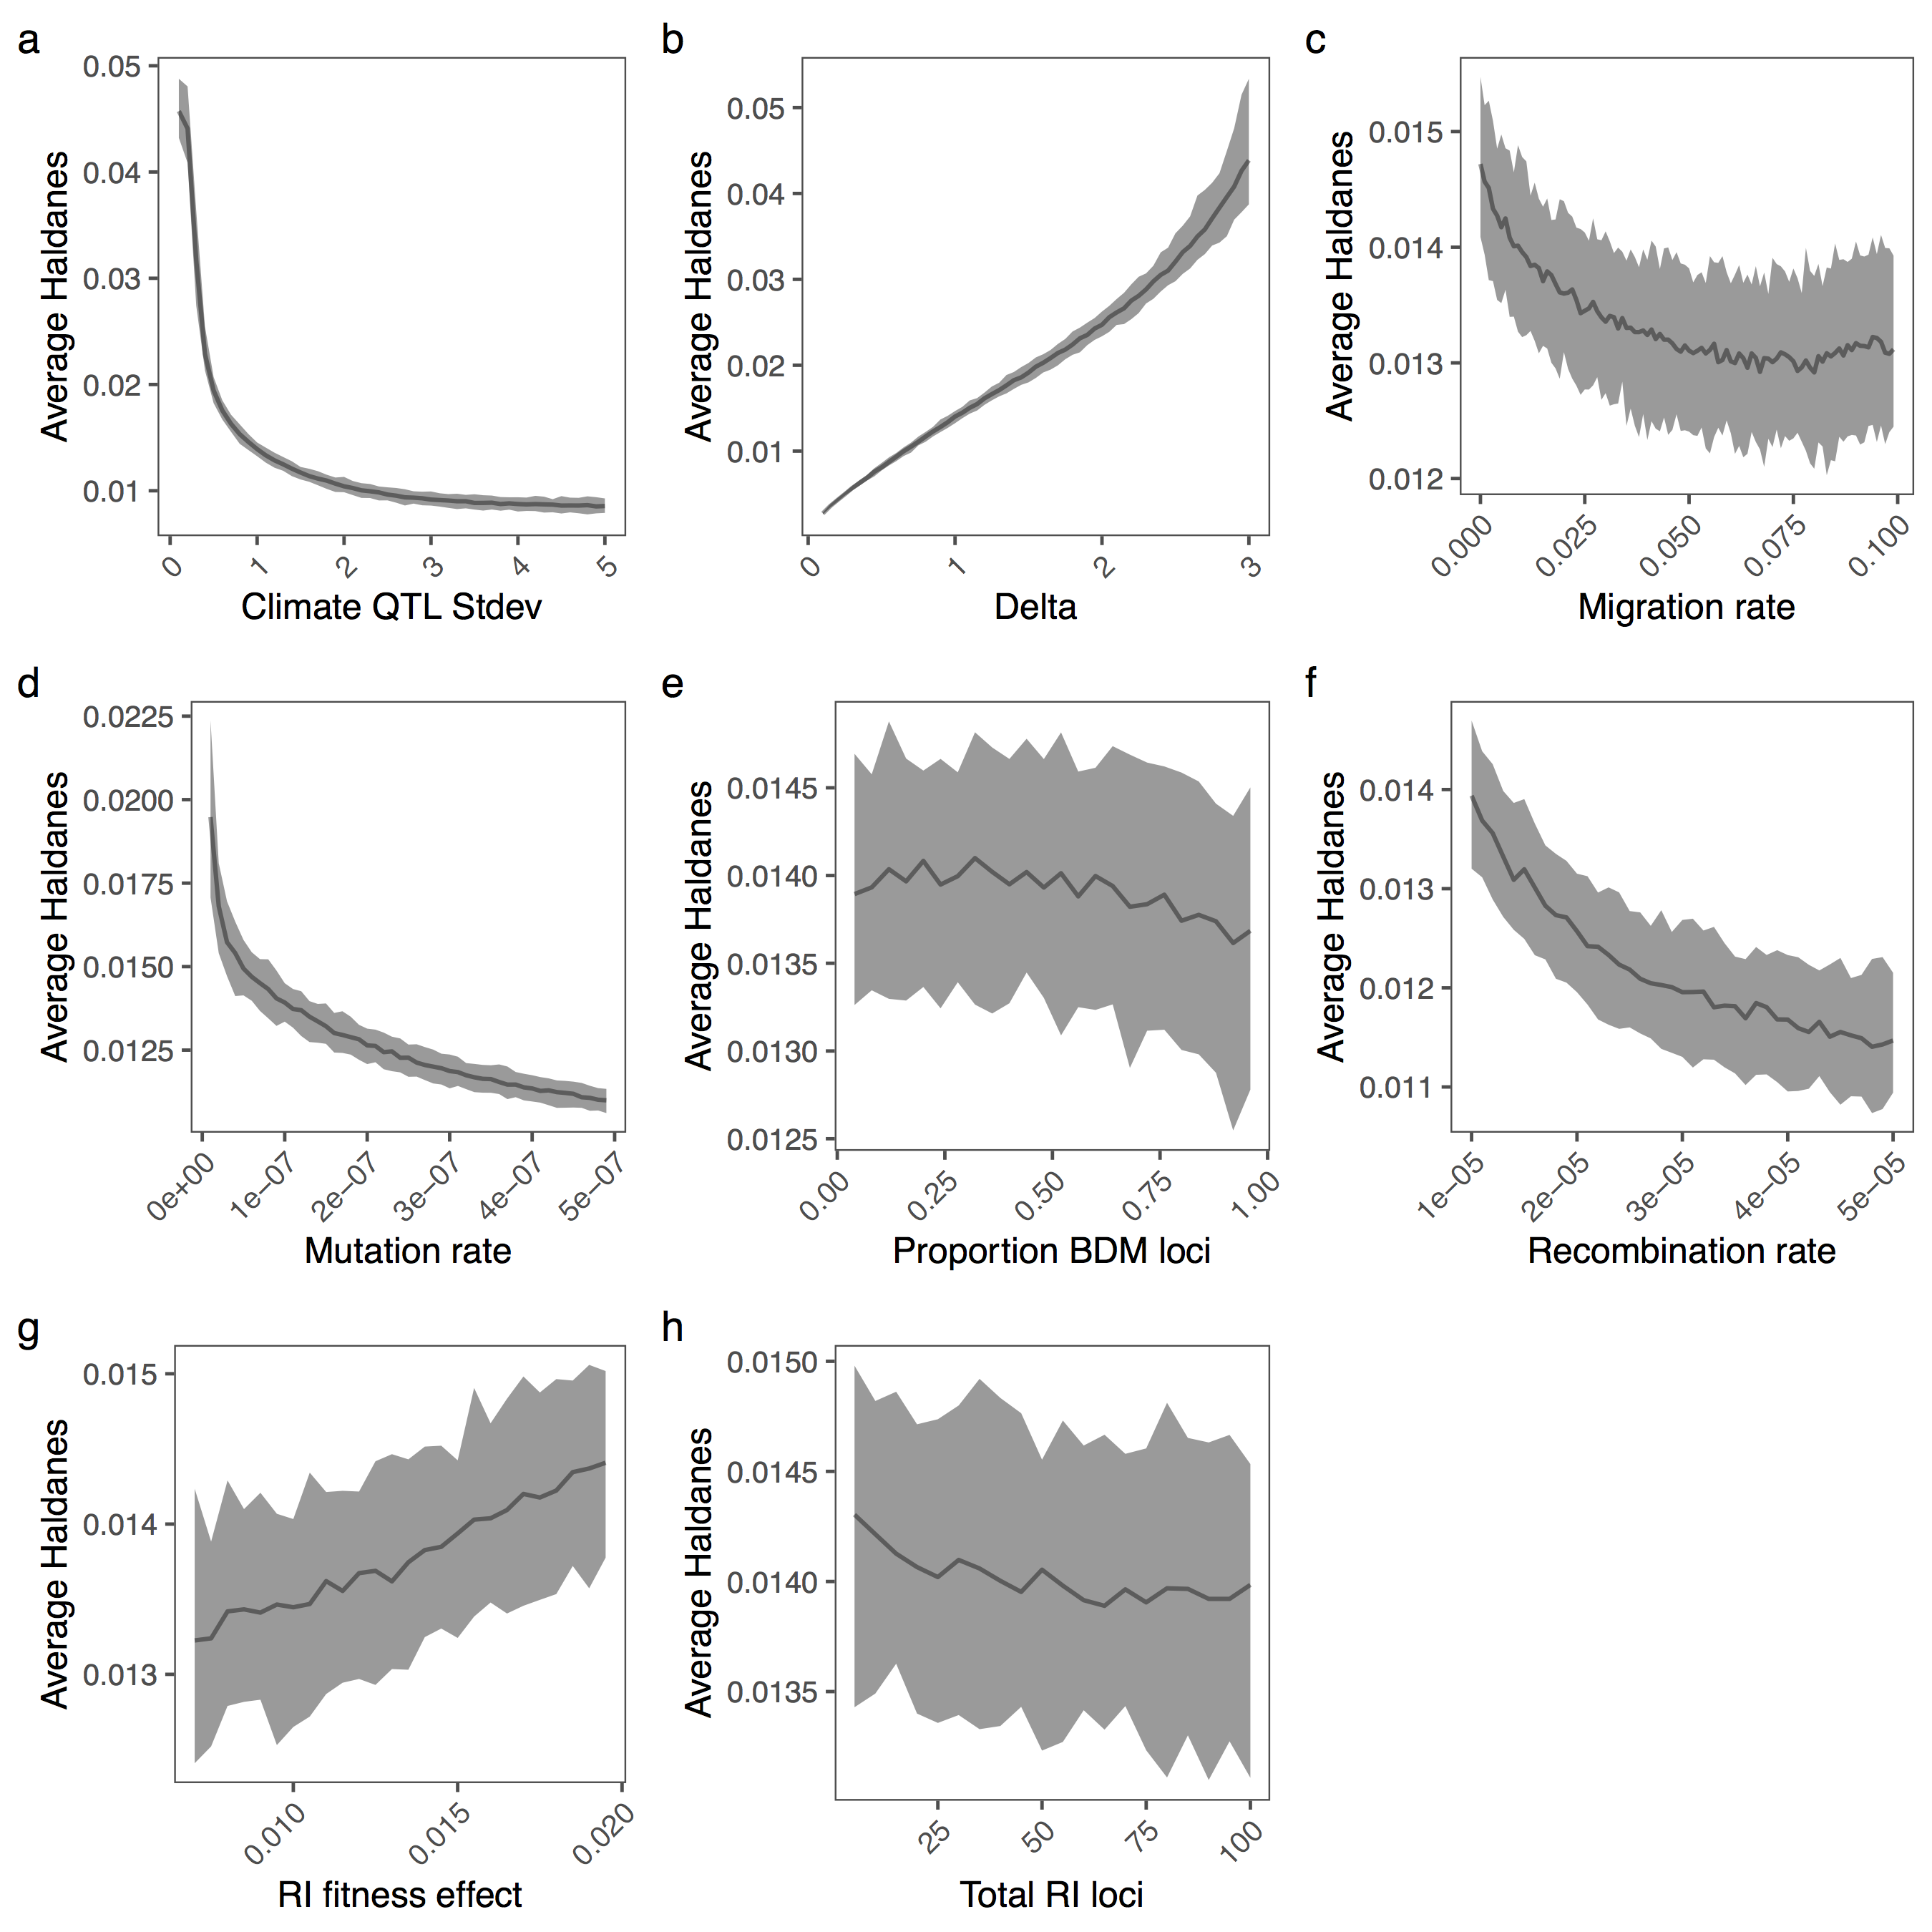**Supplementary Figure 3 | The rate of evolution during climate change.**

The average Haldanes for the post-burn in period with climate change. The shaded area encompasses 95% of the simulations. Individual parameters were varied to show the effect of (a) climate QTL effect size standard deviation, (b) optimum shift per generation (delta), (c) migration rate, (d) climate QTL mutation rate, (e) proportion of RI loci that are BDM instead of extrinsic, (f) the recombination rate, (g) the fitness effect of each RI loci and (h) the number of RI loci. Note that Haldanes are scaled by trait variation, so the same rate of absolute phenotypic change (i.e. Darwins) can have multiple different Haldanes if the phenotypic variability changes. In all panels except B, the rate of phenotypic change roughly matches the rate of environmental change, so the differences in Haldanes reflects differences in trait variance. Lower trait variance (e.g. through reduced mutation rate or lower QTL standard deviation) produces higher haldanes for the same absolute rate of phenotypic change.

## **Supplementary Table 1 | Parameters of the adaptive introgression simulations.** For each set of simulations, each parameter was set to the starting value which was varied from the minimum to maximum value by the specified increment.

|  |  |  |  |
| --- | --- | --- | --- |
| **Parameter** | **Symbol** | **Starting value** | **Range, Increment** |
| Migration rate(proportion migrants/generation) | *m* | 0.01 | 0.0-0.1, 0.001 |
| Strength of RI | *sRI* | 0.01 | 0.004-0.0195, 0.0005 |
| Number of RI loci | *l* | 100 | 5-100, 5 |
| Mutation rate (mutations/sample/locus/generation) | *μ* | 1e-7 | 1e-8-5e-7, 1e-8 |
| Climate QTL standard deviation | QTLSD | 1 | 0.1-5.0, 0.1 |
| Delta | Δ | 1 | 0.1-3, 0.1 |
| Recombination rate | *r* | 1e-5 | 1e-5-5e-5, 1e-6 |
| Proportion BDM loci | BDMpr | 0 | 0-0.96, 0.04 |
| Population size | Ne | 1000 | - |
| Environmental fitness standard deviation | *sdclimate* | 2 | - |
| Burn in generations | - | 10000 | - |
| Shift generations | - | 100 | - |
| Replicates | - | 100 | - |
| Loci on chromosome | - | 99999 | - |
| Burn in oscillation rate | *f* | 1000 | - |
| Burn in oscillation height | *a* | 5 | - |

**Supplementary Table 2** | **Genotype epistasis for BDM loci**

|  |  |  |  |
| --- | --- | --- | --- |
|  | ***aa*** | ***Aa*** | ***AA*** |
| ***bb*** | 0 | 0 | 0 |
| ***Bb*** | 0 | 2 | 2 |
| ***BB*** | 0 | 2 | 2 |

**Supplementary Table 3** | **List of parameters used in formulas.**

|  |  |
| --- | --- |
| **Symbol** | **Parameter** |
| *gen* | Generation number |
| *b* | Burn in generations |
| *f* | Burn in oscillation wavelength |
| *a* | Burn in oscillation amplitude |
| *Q* | QTL loci strength |
| *O* | Climate optimum |
| *sdclimate* | Standard deviation of gaussian climate fitness function |
| *sRI* | Selection at individual divergently selected or BDM loci |
| *s* | Realized selection coefficient |
| *l* | Total number of loci |
| *n* | Number of alleles in sample |
|  | Change in climate optimum per generation during shift |
| *g* | Sample genotype |
|  | Fitness effect |
|  | Average realized fitness |
|  | Epistasis effect |
| E | Average estimated fitness score |
|  | Reproductive isolation score |
| *N* | Population size |
| *p* | Allele frequency |

**Supplementary Table 4** | **Expected genotype frequencies for interpopulation crosses.**

|  |  |  |  |
| --- | --- | --- | --- |
|  | ***aa*** | ***Aa*** | ***AA*** |
| ***bb*** |  |  |  |
| ***Bb*** |  |  |  |
| ***BB*** |  |  |  |

**Supplementary Table 5** | **Expected genotype frequencies for intrapopulation crosses.**

|  |  |  |  |
| --- | --- | --- | --- |
|  | ***aa*** | ***Aa*** | ***AA*** |
| ***bb*** |  |  |  |
| ***Bb*** |  |  |  |
| ***BB*** |  |  |  |